DIET RECOMMENDATION-DISEASE
AIM
To write a Prolog program to suggest a suitable diet based on a given disease using facts and rules.
OBJECTIVE
· To create a disease–diet knowledge base in Prolog.
· To associate diseases with appropriate diet types.
· To use Prolog rules to retrieve diet suggestions.
· To understand knowledge representation and logical inference.
ALGORITHM
1. Start.
2. Define diseases and their corresponding diet types as facts.
3. Define the suggest_diet rule.
4. Enter the disease as a query.
5. Search the database for the matching disease.
6. If a match is found, retrieve the corresponding diet.
7. Display the suggested diet.
8. Stop.
FLOWCHART
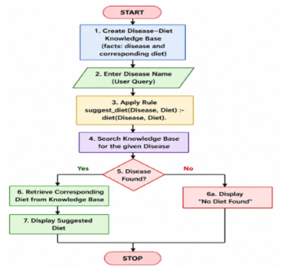
OUTPUT
diet(diabetes, low_sugar).
diet(hypertension, low_salt).
diet(obesity, low_calorie).
diet(anemia, iron_rich).
diet(heart_disease, low_fat).
suggest_diet(Disease, Diet) :-
diet(Disease, Diet).
OUTPUT
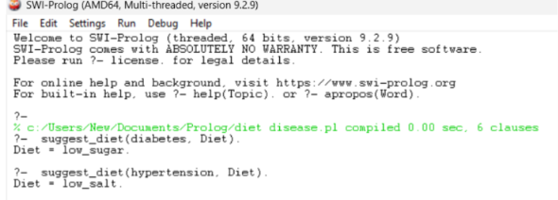
RESULT
Thus, the Prolog program was successfully implemented to suggest a diet based on the given disease, and the appropriate diet was retrieved using Prolog queries.

